Adrenaline Dance of York
Adrenaline Sparkle Purple Print Leotards
Dancer Name _________________ Parent Name________________
Phone # ______________ Email ___________________________

Cost $25 (Choose Style and Size)
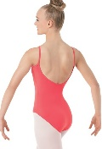
Child XS _____ SC _____ IC _____ MC _____ LC _____
Adult S _____ AM_____ AL _____ AXL _____
Black Tank Leotard ____ Black Low Back Camisole Leotard ____
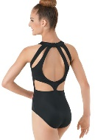
Cost $35 (Choose Size)
Black Cutout Back Tank Leotard
IC _____ MC _____ LC _____
Adult S _____ AM_____ AL _____ AXL _____

Adrenaline Dance of York
Adrenaline Sparkle Purple Print Leotards
Dancer Name _________________ Parent Name________________
Phone # ______________ Email ___________________________

Cost $25 (Choose Style and Size)
Child XS _____ SC _____ IC _____ MC _____ LC _____
Adult S _____ AM_____ AL _____ AXL _____
Black Tank Leotard ____ Black Low Back Camisole Leotard ____
Cost $35 (Choose Size)
Black Cutout Back Tank Leotard
IC _____ MC _____ LC _____
Adult S _____ AM_____ AL _____ AXL ____

